Team Pluvali

Alex Davis

Steve Kosovich

Tim Leikam

Greg Martini

Debra Parcheta

Katie Taliercio

Coping Skills Game: Detailed Testing Instructions

Steps:

1) Turn on and log in to a computer or tablet.

2)While connected to the Internet, open a browser (Internet Explorer, Firefox, Chrome, Safari, etc.) and go to: http://coping.ddrcweb.com

*You can copy the link above and paste it in the URL, as shown below.*

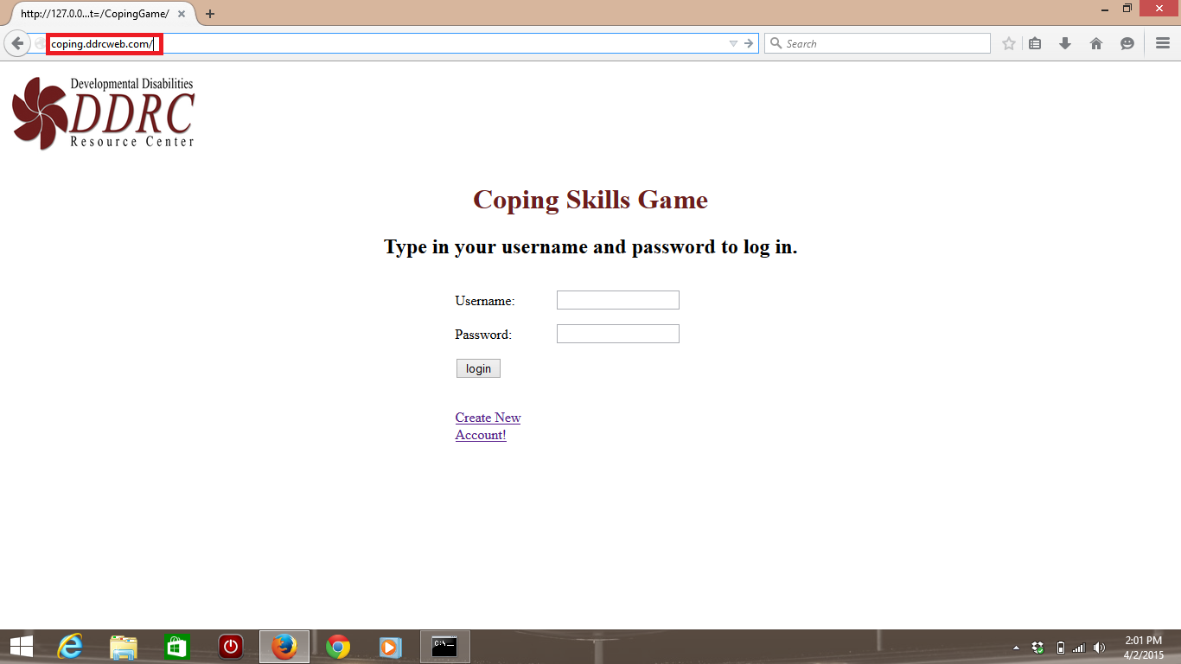

3) You are now ready to start testing the game! Click on "Create New Account!" to make your account, log in using your newly made credentials, then navigate and test the game! When finished, log out and close your web browser.

*An example of how the homepage should look when logged in is shown below.*

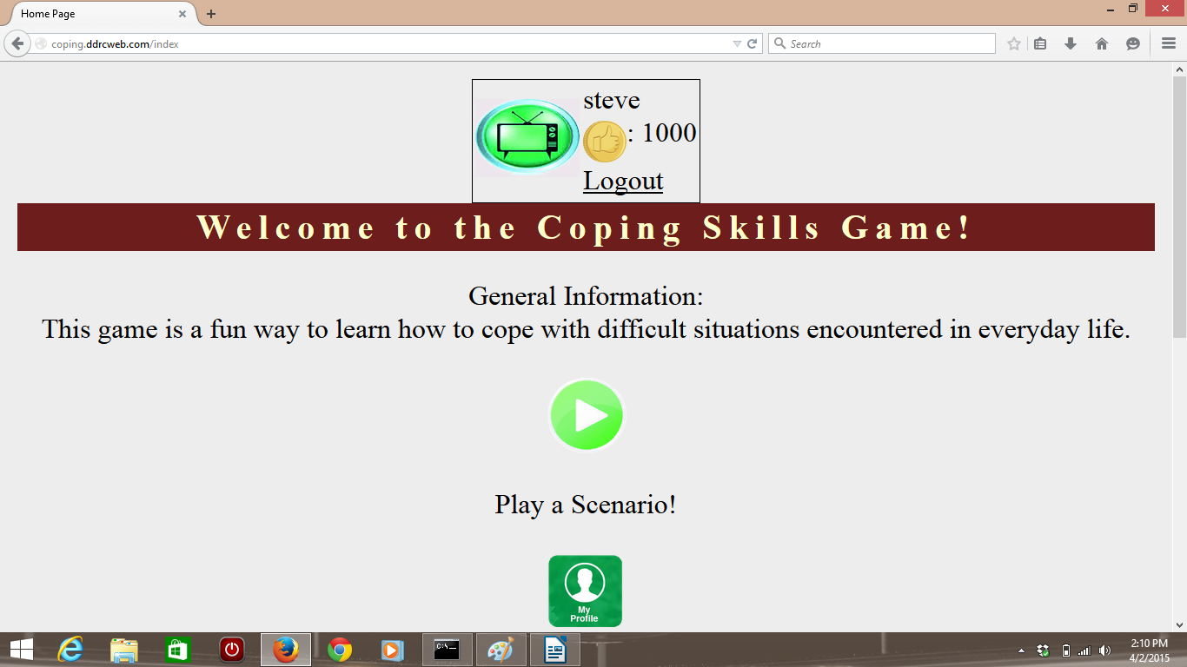

Note that for testing purposes, there are only two scenarios, and they are both listed under Television Problems. There is also a Scenario Editor in the administrator page to make new scenarios, but you must be signed in as the administrator. The testing in this plan does not include instructions on how to test the administrator page. Another document detailing how to use the administrator page will be given at a later time.